
ОБЩЕСТВО С ОГРАНИЧЕННОЙ ОТВЕТСТВЕННОСТЬЮ
«ЛАЗЕРТАГ»

ПАСПОРТ

Смоленск
LIMITED LIABILITY COMPANY
LASERWAR

SPECIFICATION

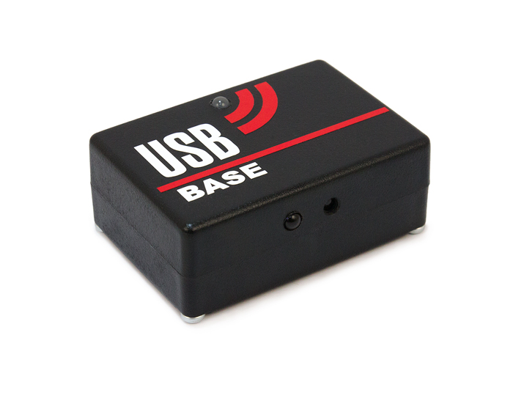
Game Set
USB-Base

Dear customer!
LLC "Lasertag" welcomes you and thanks you for choosing our products, and also expresses confidence that the product you purchased will bring you pleasure and will last a long time. This coupon establishes a warranty liability for the product in the amount provided by the Law of the Russian Federation "On Protection of Consumer Rights".
This warranty card is valid for 12 months from the date of purchase of the product subject to the terms of the guarantee.
Terms of guarantee:
1. The warranty becomes effective upon presenting this coupon, which indicates the serial number of the product and the date of purchase, confirmed by the service center.
2. These warranty obligations apply to products purchased only from the official representative of LLC "Lasertag", or its Official Dealer.
3. This warranty is void if defects in the product have occurred in the event of:
- non-observance of Instructions for use;
- mechanical damage;
- ingress of foreign objects, liquids, etc .;
- animal activities;
- unauthorized access to the units and parts of the product of persons not authorized to carry out the specified actions;
- use of the product for purposes for which it is not provided;
- acts of force majeure (natural disaster, fire, accident, etc.);
- failure of the product due to incorrect connection, a faulty electrical outlet and / or poor maintenance of the product.
4. If the warranty card is lost, a duplicate is not issued.

10. Contact Information

official site:
www.laserwar.com

email:
info@laserwar.com
help@laserwar.com

skype:
info@laserwar.com
help@laserwar.com purchase date:______________

______________________________________
signature

2
7
Information about the repairs carried out during the warranty service (to be completed by the service center performing the warranty repair)

Date:__________________Completed work:  _____________________________________________________________________  Printing Service Center | Date:__________________  Completed work:  _____________________________________________________________________  Printing Service Center
Date:__________________Completed work:  _____________________________________________________________________  Printing Service Center | Date:__________________Completed work:  _____________________________________________________________________  Printing Service Center
Date:__________________Completed work:  _____________________________________________________________________  Printing Service Center | Date:__________________Completed work:  _____________________________________________________________________  Printing Service Center

1. Description
"USB Base" is designed for programming laser tag guns and removing game statistics on an infrared channel.

2. Scope of application
The device is designed for programming laser tag guns and the removal of game statistics on the infrared channel, and is used in organizing sports events, tactical training, corporate and entertainment events.
3. Package Contents
1. USB Base - 1 pc.
2. USB cable for connection to a computer - 1 pc.
3. Product passport - 1 pc.

4. Basic technical data
Height, mm | 30
Width, mm | 50
Length, mm | 70
Supply voltage, V | 5
Number of IR emitters, pcs. | 1
Number of photo sensors, pcs. | 1
Weight, kg | 0,045

5. Device
"USB Base" is made in a plastic case in black. The main body is a structure in which control units and module fastening elements are installed.

6. Maintenance
For the normal operation of the equipment, care must be taken for all the elements of the kit. Avoid contamination and damage to the IR diode and photosensor. Do not allow moisture to enter the cabinet. Avoid strikes.

3
6
7. Instructions for use
Connect the base to a computer or laptop. Install the driver for the database (located on the supplied DVD disc, as well as on the site in the corresponding section). Run the LASERWAR v4.7 software. The gun and sensors should be located opposite the base.

Turn on the gun in the administration mode. Point the gun barrel at the center of the base, and place the bandage exactly opposite the base not more than 1 meter. With the correct connection of the gun, the bandage will start blinking with LEDs, the program will show the connection of a specific ID of the gun. All the settings that were stitched in the equipment can be viewed by clicking the "Read" button. To change the TTX of the equipment, you can use the proposed settings or change them manually.

Then click on the "Record" button. The bandage blinks; A few seconds and you're done. Make sure that the unique player ID and the correct color of the team are displayed. Click "OK", the hardware will reboot. Reprogramming is complete.

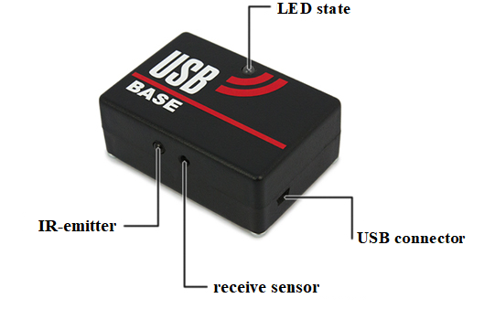

Fig.1 Basic elements of USB Base

Rules of operation of equipment

1. Weather conditions. In the production process, the equipment is tested for operation under various weather conditions. Despite this, we strongly do not recommend using the equipment in rain and temperatures below -20 ° C.
What do you need to know when operating gaming kits in adverse weather conditions?
Most importantly, avoid getting moisture inside the device. If this happens - stop operation, dry the equipment at room temperature for at least 2 hours.

2. Power source. The battery itself is not in the USB-base. Power is supplied directly when the USB-base is connected to the computer.
Store the equipment in a well-ventilated place at a temperature of +18 ° C to +30 ° C and relative humidity of 45 to 65%.
On the batteries, speakers, IR modules, the warranty is 14 DAYS. These accessories are consumables.

ATTENTION! In the event of improper use of batteries (charging by an inappropriate type of charger), the battery warranty does not apply!

8. Changing the settings of the game set
USB Base
There is no change in the settings for this device.

9. Warranty
The manufacturer guarantees the reliability of the operation of the individual "LASERWAR" kit, provided that the user meets the operating conditions. Technical support is provided within 12 months from the date of sale. The manufacturer undertakes to replace or repair the individual set of equipment free of charge, provided that the consumer observes the rules of transportation, storage, operation and payment for the delivery of faulty equipment to the city of Smolensk.

4
5

